**Sailors Average Experience**



**Sailors and Rider Details**



**Sailor with Passengers Travelled**



**Boat Details based on Riding Date**



**Sailors from the Same City**



**Details based on New Date**



**Sailor Details and Shifts**



**Sailor with Shift Update**

**Sailor with Boat Details**

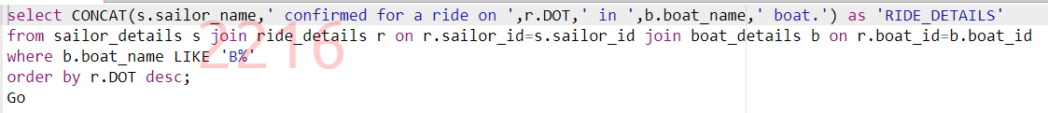

**Boat Details based on Count**



**Display Boat Details**



**Sailor Details with Maximum Experience**



**Boat Details having Minimum Seat Capacity**

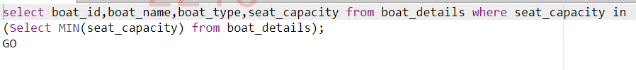

**Average Seating Capacity**



**Recently joined Sailor Details**



**Sailor Details**



**Boat Details based on Rides**



**Sailor Details with Formatted Phone Number**

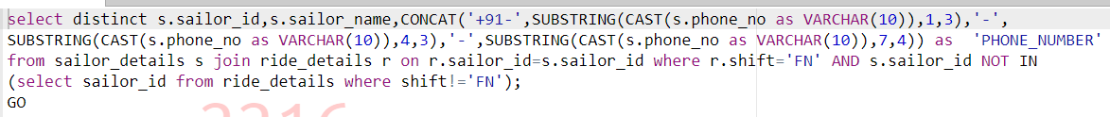

**Display Boat Type**



**Display Sailor Ride**



**Display Ride Code**

